

CBD GRANT GUIDELINES 2020/2021

The CBD fund is open to owners or managers of Commercial buildings located in the B3 Commercial Core Zone of the Local Environmental Plan 2009. See the light blue area in the map below.

The area is bounded by the eastern side of Bourke Street, the western side of Sloane Street, the Southern side of Bradley Street & the northern side of Clinton Street.

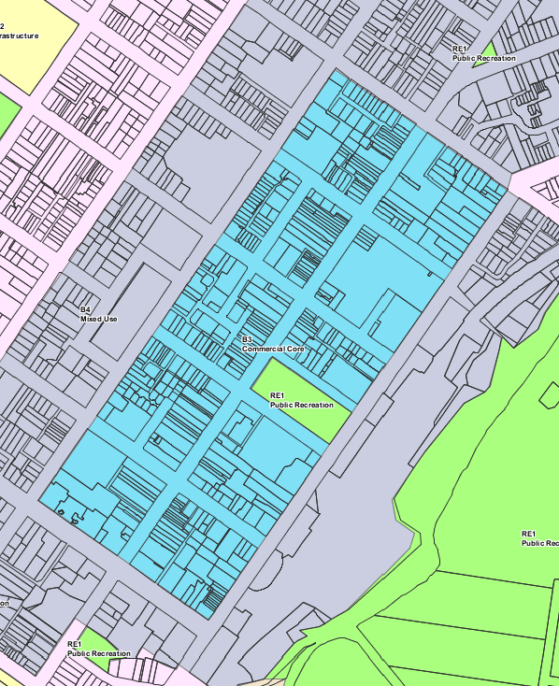

The closing date for grant applications is Tuesday 28 July 2020.
Funding won’t be provided if the work has commenced prior to a grant offer being made.

Please retain these guidelines and submit only the application form.

BACKGROUND

Goulburn Mulwaree Council has established a CBD Fund to provide grants to owners or managers of CBD buildings.

AIM OF THE FUND

The aim of the fund is to encourage positive work on CBD buildings. The program will provide kick-start funding for a number of projects. It is hoped that grant funding will create greater interest and concern for the conservation of buildings located in Goulburn’s CBD.

LEVEL OF FUNDING AVAILABLE

A total of $25,000 is available. Amounts will be allocated based on the significance of the building and the work proposed. The grants are dollar for dollar, that is Council will match each dollar spent by the applicant up to the maximum grant amount offered. There will be cases where the applicant wishes to contribute more funds to the project.

INVITATION TO APPLY

The 2020/2021 fund is open to owners and managers of Commercial buildings located in the B3 Commercial Core zone of the Local Environmental Plan 2009, Goulburn Mulwaree (see map on previous page).

It is essential that the best application possible be submitted as the funds available are limited and only projects that are most beneficial to heritage conservation will be funded.

ELIGIBLE PROJECTS

Projects are eligible if they are for the external painting and or conservation or replacement of original details.

GRANT ASSESSMENT CRITERIA

Council will take the following matters into account in assessing the priority of your application. Please note that it is not necessary for your project to meet all of these criteria:

- technical and financial ability to complete the project by Friday 15 May 2021
- the degree to which the applicant is financially contributing to the project
- projects that clearly complement broader conservation objectives, e.g. projects which implement key findings of heritage studies
- projects that are highly visible to the public, e.g. the replacement of a verandah
- urgent projects to avert threat to a heritage item
- owners with outstanding council rates are ineligible to receive grant funding

PREVIOUS GRANT APPLICANTS

Preference will be given to applicants who have not received CBD grant funding previously. Applications from previously successful applicants will be considered if funds are available.

UNSUCCESSFUL APPLICATIONS

If your application is unsuccessful this year you can request that it be reconsidered in the next grant funding year. Unsuccessful applications will be placed on a reserve list in priority order in case any of the successful applicants do not undertake their grant work.

TIMING OF PROJECTS

Critical dates are;
- The closing date for grant applications is 4.30 pm Tuesday 28 July 2020
- Grant work is to be commenced on site by Monday 15 February 2021
- Work must be completed and payment claimed by Friday 15 May 2021

NB: To claim payment the contractor must have been paid. Please provide Council with copies of receipts confirming payment and digital photos of the completed work.

WHAT YOU NEED TO DO

If you have any questions in relation to the type of work you propose to carry out contact
Mr Jack Miller, or Mr Nick Thistleton at Council's Strategic Planning section, on phone
4823 4444.

Council's Heritage Adviser can recommend suitable conservation methods and give other advice, this is a free service provided by Council. Phone Council's Strategic Planning section to make an appointment with the Heritage Adviser.

BACKGROUND RESEARCH

It will assist your application if you can show why the work you propose is appropriate from a heritage point of view.

You may need to do some research e.g. obtain information on the building or item and refer to historic photographs. Possible sources of information are the Council’s building records, the Library Local History room or History Goulburn (Goulburn District Historical & Genealogy Society). Council’s heritage adviser may also have suggestions to follow up.

WORK TO BE CARRIED OUT

Decide in detail what work you want to carry out in an itemised job schedule.

QUOTES

Copies of quotes are to be submitted with your application. It is suggested that you get at least two quotes for the proposed work. Where owners intend to carry out the work themselves Council will part fund the purchase of materials but not the labour of the owners. In this instance obtain quotes for the purchase of materials.

Council does not necessarily require that the lowest quote be accepted.

PLANS AND SKETCHES

Depending on the type or size of the job you may need to attach plans or sketches to your application for funding. Some proposed work might require Council Development Application approval for example the construction of a verandah.

PHOTOGRAPHS

Take a photograph of the setting of the building, each relevant elevation and close ups of the particular jobs to be done. Please include digital colour photographs with your application. Keep copies of the photographs for your own records.

FILL IN THE APPLICATION FORM

Fill in the application form, include the attachments and submit them to Council. Keep a copy for your records.

Please retain these grant guidelines for your information in the management of the grant work.

SUBMITTING APPLICATIONS

Applications received by the closing date will be judged on merit against the grant assessment criteria (see page 2). Please submit;
- The application form signed by all owners of the property,
- Digital colour photographs
- Copies of quotes
- Any relevant supporting documentation

NOTIFICATION OF OUTCOME OF APPLICATION

Council’s will assesses the applications and a report will be put to Council to determine which applications are offered funding and which are placed on a prioritised reserve list. Following resolution by Council applicants are then informed by letter of the outcome. Applicants are advised of the outcome in September/October.

PAYMENT OF SUCCESSFUL APPLICATIONS

Work must be complete, fixed in place permanently and be paid for in full by the applicant prior to claiming payment of the grant from Council.

Copies of receipts of payment and electronic colour photographs of completed work must be supplied to Council prior to 5pm Friday 15 May 2021 to claim the grant payment. Claims for payment lodged after this date will not be paid.

PLEASE NOTE

Council can’t carry grant funds over from one year to the next. If you are not able to do the work described in the grant application for any reason please advise Council ASAP so that the money can be offered to someone else. Projects are to be commenced by Monday 15 February 2021 otherwise Council reserves the right to withdraw the grant funding and offer it to another applicant.

INFORMATION FROM GRANT APPLICATIONS IS OPEN TO THE PUBLIC

Council’s grant application process is open for public scrutiny. Information from applications is included in Council’s Business Paper; this will include the address of applicants. Once information is included in the Business Paper it becomes public and may be used by the media or placed on Council’s web site.

CBD GRANT APPLICATION 2020/2021
Goulburn Mulwaree Council

PLEASE REFER TO THE GUIDELINES BEFORE COMPLETING THIS APPLICATION

APPLICANT DETAILS
NAME:
POSTAL ADDRESS:
PHONE NUMBER(S):
EMAIL:
ADDRESS OF CBD PROPERTY Please include name of building if any.
ADDRESS:
THE PROPOSAL
PROPOSED WORKS:
PRESENT USE OF BULDING:
COST
ESTIMATED COST OF THE WORK:
AMOUNT SOUGHT FROM THIS APPLICATION:
Note: Grant amounts will be allocated based on the significance of the building and the work proposed. The grants are dollar for dollar, that is Council will match each dollar spent by the applicant up to the maximum grant amount offered.

ADDITIONAL INFORMATION SUBMITTED WITH THIS APPLICATION
Items shown with an asterisk * are mandatory. Applications without this information can not be processed.
TICK THE APPROPRIATE BOXES – SEE GUIDELINES FOR FURTHER DETAILS
* Quotes for the cost to carry out the work (preferably minimum 2 quotes).
* Digital photographs of the existing structure.
Plans / Details / Sketches of the proposed work (if relevant).

Samples of finished materials and paint colours. These must be
agreed with Council prior to start of work.
APPLICANT(S) SIGNATURE
I/we, the undersigned, being the applicant(s) nominated in this application, hereby apply for financial assistance under the CBD Assistance Fund to carry out works described in this application on the land specified in this application.

………………………………………………………………………………………………………………………………………………………………………………………………….……………
NAME SIGNATURE CAPACITY (e.g. owner or tenant) DATE

………………………………………………………………………………………………………………………………………………………………………………………………….……………
NAME SIGNATURE CAPACITY DATE

CONSENT OF OWNER(S) OF THE LAND
Note: Only required if the applicant is not the owner.
OWNER(S) DETAILS:

POSTAL ADDRESS:

………………………………………………………………………………………………………………………………………………………………………………………………….……………
NAME SIGNATURE CAPACITY DATE

………………………………………………………………………………………………………………………………………………………………………………………………….……………
NAME SIGNATURE CAPACITY DATE
Note: The signature of all owners is required.

